Food Wish List

The Cambria County Backpack Project is always looking for groups, organizations, and businesses to hold food drives to help the CCBP in providing weekend meals for students.

If you wish to hold a food drive, we encourage you to pick one or two items from the list below. All items must be single serve or individually wrapped, boxed, or canned. We ask that you refrain from donating items with nuts or peanut butter as we are unable to give those items out to the children.

If you have any questions, contact the CCBP Coordinator at ccbpcoordinator@thelearninglamp.org or call 814-262-0732 ext. 312.
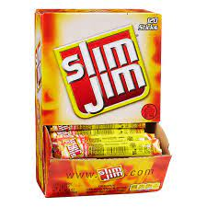
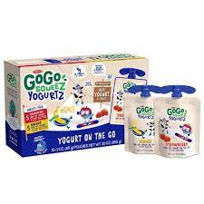
- Granola bars
- Slim Jims
- Ramen noodle cups
- Fruit cups
- Mac & Cheese cups
- Whole grain snacks
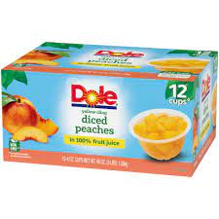
- Go Go Squeeze Yogurt
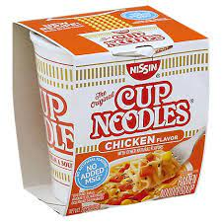
- Chef Boyardee Meals

